CYCLE-4
PART-1
1. Using the iris data set implement the KNN algorithm. Take different values for Test and training data set .Also use different values for k. Also find the accuracy level.
Program
import numpy as np
import matplotlib.pyplot as plt
import seaborn as sns
import pandas as pd
irist = sns.load_dataset('iris')
dataset = pd.DataFrame(irist)
dataset.head()
X = dataset.iloc[:, :-1].values
y = dataset.iloc[:, 4].values
from sklearn.model_selection import train_test_split
X_train, X_test, y_train, y_test = train_test_split(X, y, test_size=0.30)
from sklearn.preprocessing import StandardScaler
scaler = StandardScaler()
scaler.fit(X_train)
X_train = scaler.transform(X_train)
X_test = scaler.transform(X_test)
from sklearn.neighbors import KNeighborsClassifier
classifier = KNeighborsClassifier(n_neighbors=5)
classifier.fit(X_train, y_train)
y_pred = classifier.predict(X_test)
from sklearn.metrics import classification_report, confusion_matrix
print(confusion_matrix(y_test, y_pred))
print(classification_report(y_test, y_pred))
output
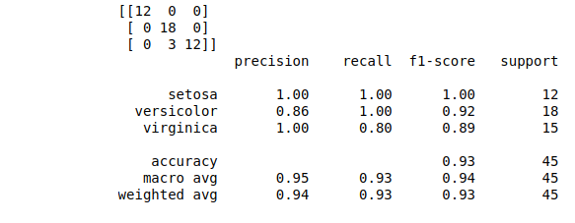

2. Download another data set suitable for the KNN and implement the KNN algorithm. Take different values for Test and training data set .Also use different values for k.
Program

output

3. Using iris data set, implement naive bayes classification for different naive Bayes classification algorithms.( (i) gaussian (ii) bernoulli etc)
- Find out the accuracy level w.r.t to each algorithm
- Display the no:of mislabeled classification from test data set
List out the class labels of the mismatching records
Program
output
4.Use car details CSV file and implement decision tree algorithm

- Find out the accuracy level.
- Display the no:of mislabeled classification from test data set
- List out the class labels of the mismatching records

Program
output

PART -2 REGRESSION

Implement Simple and multiple linear regression for the data sets ‘student_score.csv’ and ‘company_data .csv’ respectively

PROGRAM
OUTPUT

PART -3 NEURAL NETWORK
Experiment:
- Create a neural network for the given ‘houseprice.csv’ to predict the whether price of the house is above or below median value or not

Keras allows you to train your model using stochastic, batch, or minibatch gradient descent.
- Batch Gradient Descent. Batch size is set to the total number of examples in the training dataset.
- Stochastic Gradient Descent. Batch size is set to one.
- Minibatch Gradient Descent. Batch size is set to more than one and less than the total number of examples in the training dataset.

Cost Functions
The three most common loss(cost) functions are:
- ‘binary_crossentropy‘ for binary classification.
- ‘sparse_categorical_crossentropy‘ for multi-class classification.
- ‘mse‘ (mean squared error) for regression.

Different Optimizers
- SGD.
- RMSprop.
- Adam.
- Adadelta.
- Adagrad.
- Adamax.
- Nadam.
- Ftrl.

Fit the Model
Fitting the model requires that you first select the training configuration, such as the number of epochs (loops through the training dataset) and the batch size (number of samples in an epoch used to estimate model error).

A subset of the training dataset is used to estimate the error and update the weights.
The number of examples from the training dataset used in the estimate of the error gradient is called the batch size

A batch size of 32 means that 32 samples from the training dataset will be used to estimate the error gradient before the model weights are updated. One training epoch means that the learning algorithm has made one pass through the training dataset, where examples were separated into randomly selected “batch size” groups.

Activation Functions
ReLU function is suitable for using in hidden layers
Sigmoid function is commonly used in output layer for binary classification
Softmax activation function should be used in the output layer in case of multiclass classification.

